Program vs. Software
Software is more than programs. Any program is a subset of software, and it becomes software only if documentation & operating procedures manuals are prepared.
There are three components of the software as shown in fig:
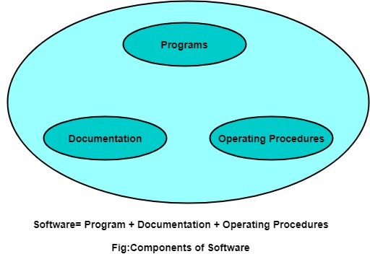
1. Program: Program is a combination of source code & object code.
2. Documentation: Documentation consists of different types of manuals. Examples of documentation manuals are: Data Flow Diagram, Flow Charts, ER diagrams, etc.
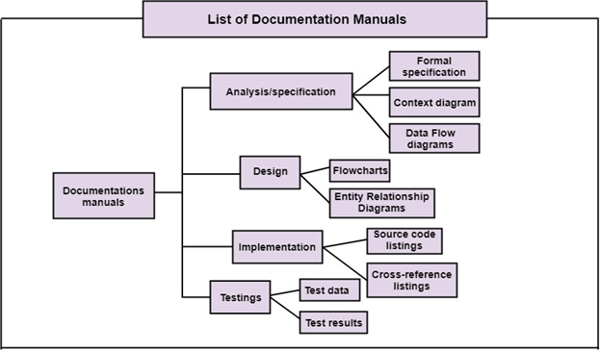
3. Operating Procedures: Operating Procedures consist of instructions to set up and use the software system and instructions on how react to the system failure. Example of operating system procedures manuals is: installation guide, Beginner's guide, reference guide, system administration guide, etc.
